### **Team Smiley - Release Plan 1.0**

**Iteration Length**

The iteration length of each iteration is 14 days and the first iteration release date is March 20, 2019 and the second iteration release date is April 3, 2019.

**Must Have Stories**

|  |  |
| --- | --- |
| Story | Estimate |
| As a student/faculty I want to login to CenEats so that I can view the available restaurants. | 2 |
| As a administrator I want to login so I can start monitoring CenEats. | 2 |
| As a student/faculty I want to choose a restaurant so I can begin ordering food. | 1 |
| As a student/faculty I want to order an item from a restaurant so I can add it to my order | 4 |
| As a student/faculty I want to purchase my order so I can confirm my order. | 2 |
| As a student/faculty I want to view my order history so I can make sure my recent order was successfully submitted. | 2 |
| As a student/faculty I want to delete an order so I can cancel my order. | 2 |
| As a student/faculty I want to view other students/faculty reviews so I can benefit from other peoples experiences at restaurants. | 2 |
| As a student/faculty I want to write a review so that I can state my opinion. | 3 |
| As a Customer Service Rep I want to delete a student/faculty review so inappropriate restaurant reviews can be removed. | 2 |
| As a Restaurant staff I want to login to CenEats so I can view orders that need to be prepared. | 4 |
| As a Restaurant Manager I want to update the stock status of an item to empty so customers can stop ordering that item. | 5 |

**Should-Have Stories**

|  |  |
| --- | --- |
| Story | Estimate |
| As a student/faculty I want to update an order so I can change the quantity of my order items. | 3 |
| As a faculty I want to use a promo code on my order so I can receive a discount. | 3 |
| As a student/faculty I want to update my review so I can fix any mistakes publicly viewed by other customers. | 3 |
| As a Website Maintenance Manager I want to monitor CenEats performance so I can measure their status. | 5 |

**Could-Have Stories**

|  |  |
| --- | --- |
| Story | Estimate |
| As a student/faculty I want to be able to track my order so I can know when my order is ready | 5 |

**Won’t-Have Stories**

|  |  |
| --- | --- |
| Story | Estimate |
| As a student/faculty I want the option to have my order delivered to my destination so I don’t have to leave my destination to collect my order. | 5 |

**Refined Must And Should have Priority Stories**

|  |  |  |  |  |  |
| --- | --- | --- | --- | --- | --- |
| **Authentication** | **Home page** | **Order** | **Review** | **Admin** | **Restaurant** |
| As a student/faculty I want to login to CenEats so that I can view the available restaurants. | As a student/faculty I want to choose a restaurant so I can begin ordering food. | As a student/faculty I want to order an item from a restaurant so I can add it to my order | As a student/faculty I want to view other students/faculty reviews so I can benefit from other peoples experiences at restaurants. | As a Website Maintenance Manager I want to monitor CenEats performance so I can measure their status. | As a Restaurant Manager I want to update the stock status of an item to empty so customers can stop ordering that item. |
| As a administrator I want to login so I can start monitoring CenEats. |  | As a student/faculty I want to purchase my order so I can confirm my order. | As a student/faculty I want to write a review so that I can state my opinion. | As a Customer Service Rep I want to delete a student/faculty review so inappropriate restaurant reviews can be removed. |  |
| As a Restaurant staff I want to login to CenEats so I can view orders that need to be prepared. |  | As a student/faculty I want to view my order history so I can make sure my recent order was successfully submitted. | As a student/faculty I want to update my review so I can fix any mistakes publicly viewed by other customers. |  |  |
|  |  | As a student/faculty I want to delete an order so I can cancel my order. |  |  |  |
|  |  | As a student/faculty I want to update an order so I can change the quantity of my order items. |  |  |  |
|  |  | As a faculty I want to use a promo code on my order so I can receive a discount. |  |  |  |

**Team Smiley - Application Layout Design - Paper prototype**

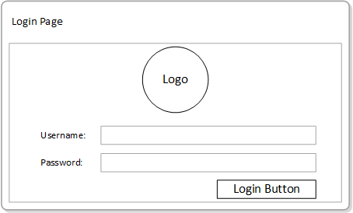

|  |
| --- |
| **Authentication** |
| As a student/faculty I want to login to CenEats so that I can view the available restaurants. |
| As a administrator I want to login so I can start monitoring CenEats. |
| As a Restaurant staff I want to login to CenEats so I can view orders that need to be prepared. |

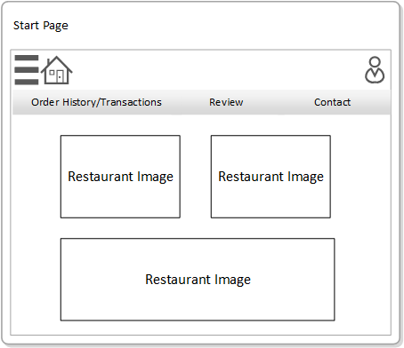

|  |
| --- |
| **Home page** |
| As a student/faculty I want to choose a restaurant so I can begin ordering food. |

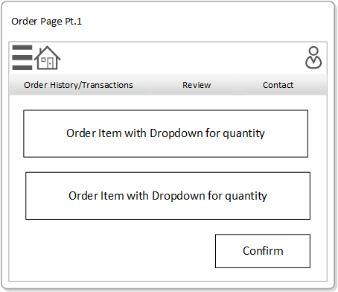

|  |
| --- |
| **Order - Create Order** |
| As a student/faculty I want to order an item from a restaurant so I can add it to my order |

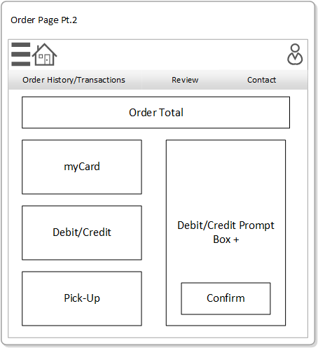

|  |
| --- |
| **Order - Payment** |
| As a student/faculty I want to purchase my order so I can confirm my order. |

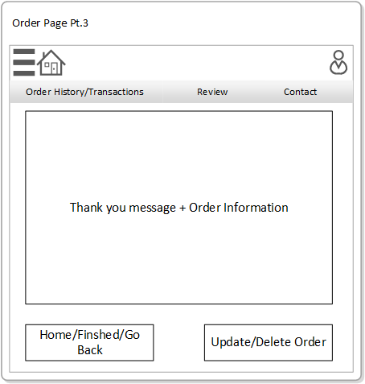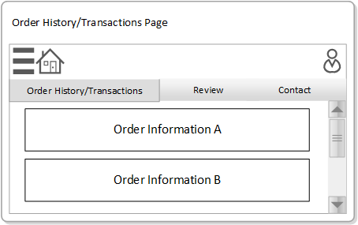

|  |
| --- |
| **Order - View Order** |
| As a student/faculty I want to view my order history so I can make sure my recent order was successfully submitted. |

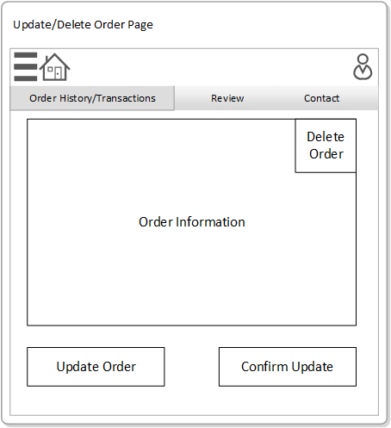

|  |
| --- |
| **Order - Update and Delete** |
| As a student/faculty I want to delete an order so I can cancel my order. |
| As a student/faculty I want to update an order so I can change the quantity of my order items. |

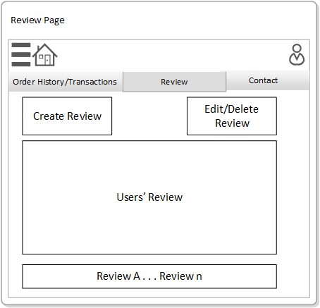

|  |
| --- |
| **Review - view review** |
| As a student/faculty I want to view other students/faculty reviews so I can benefit from other peoples experiences at restaurants. |

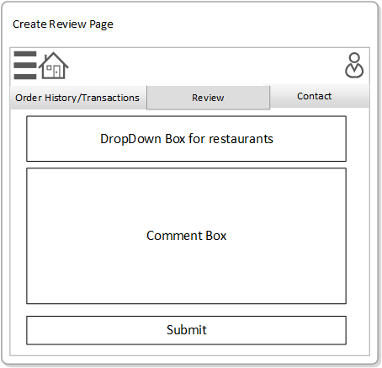

|  |
| --- |
| **Review - create review** |
| As a student/faculty I want to write a review so that I can state my opinion. |

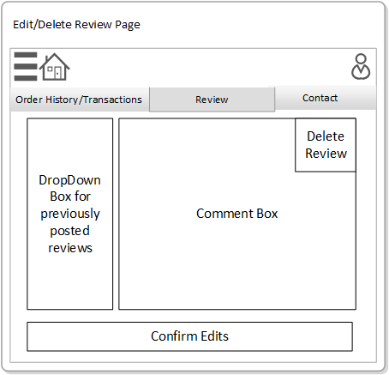

|  |
| --- |
| **Review - Edit/Delete** |
| As a student/faculty I want to update my review so I can fix any mistakes publicly viewed by other customers. |
| As a Customer Service Rep I want to delete a student/faculty review so inappropriate restaurant reviews can be removed. |

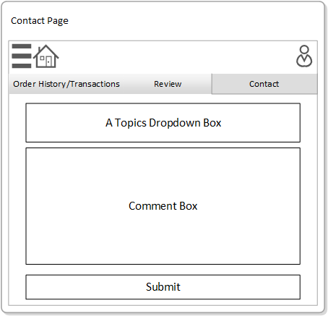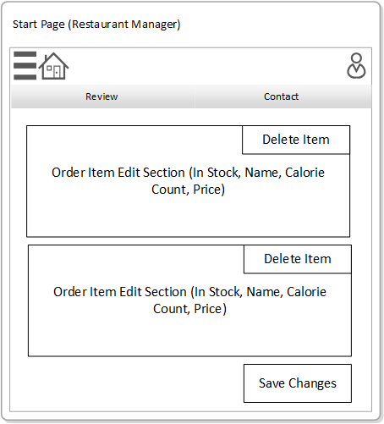

|  |
| --- |
| **Restaurant - Delete Order** |
| As a Restaurant Manager I want to update the stock status of an item to empty so customers can stop ordering that item. |

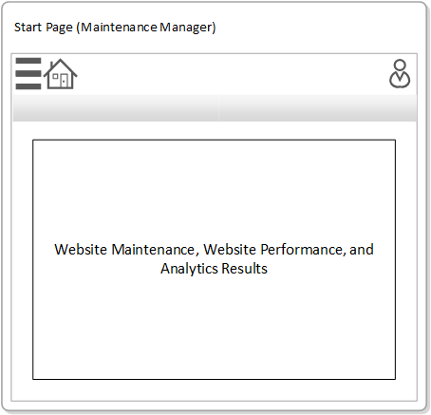

|  |
| --- |
| **Admin** |
| As a Website Maintenance Manager I want to monitor CenEats performance so I can measure their status. |

**Release Plan**

|  |  |
| --- | --- |
| Iteration 1 (March 20, 2019) | Iteration 2 (April 3, 2019) |
| As a student/faculty I want to login to CenEats so that I can view the available restaurants. | As a student/faculty I want to view other students/faculty reviews so I can benefit from other peoples experiences at restaurants. |
| As a administrator I want to login so I can start monitoring CenEats. | As a student/faculty I want to update an order so I can change the quantity of my order items. |
| As a Restaurant staff I want to login to CenEats so I can view orders that need to be prepared. | As a faculty I want to use a promo code on my order so I can receive a discount. |
| As a student/faculty I want to choose a restaurant so I can begin ordering food. | As a Customer Service Rep I want to delete a student/faculty review so inappropriate restaurant reviews can be removed. |
| As a student/faculty I want to order an item from a restaurant so I can add it to my order | As a Restaurant Manager I want to update the stock status of an item to empty so customers can stop ordering that item. |
| As a student/faculty I want to purchase my order so I can confirm my order. | As a student/faculty I want to write a review so that I can state my opinion. |
| As a student/faculty I want to view my order history so I can make sure my recent order was successfully submitted. | As a student/faculty I want to update my review so I can fix any mistakes publicly viewed by other customers. |
| As a student/faculty I want to delete an order so I can cancel my order. | As a Website Maintenance Manager I want to monitor CenEats performance so I can measure their status. |